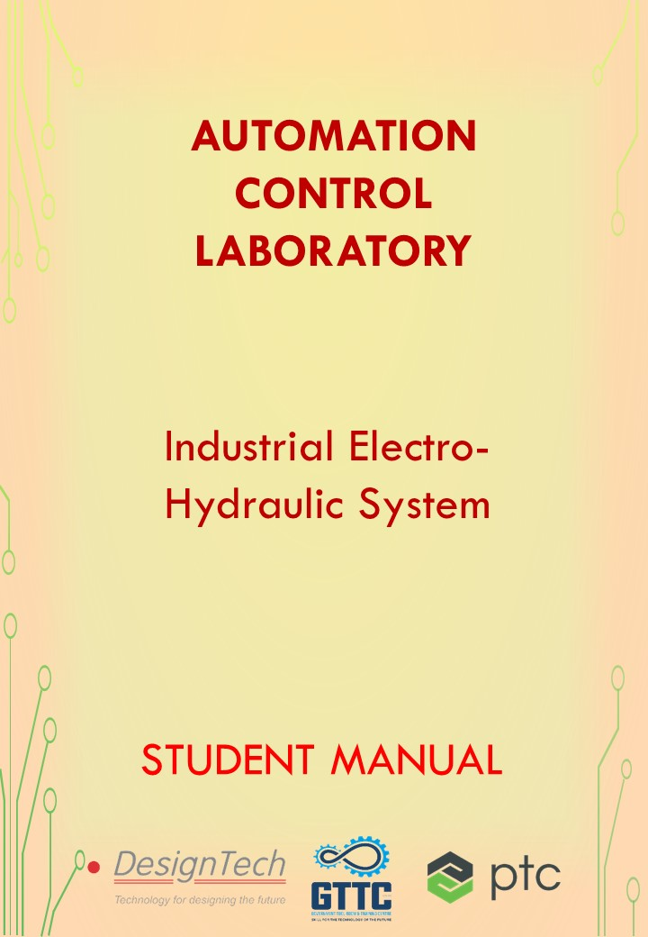

**AUTOMATION CONTROL LABO RATORY**

In this lab we use different types of Automation and control techniques, we will work on the different applications according to real-time industry scenarios. Understand the role of programmable logic controllers in complex mechatronic systems, modules, and subsystems.



The list of courses offered,

|  |  |  |  |
| --- | --- | --- | --- |
| S.No | Name of the Course | | Duration |
| 1 | | Basics of PLC | 50 Hours |
| 2 | | Basic SCADA | 50 Hours |
| 3 | | Industrial Level control and Batch Process Reactor System | 30 Hours |
| 4 | | Process Instrumentation Technology | 30 Hours |
| 5 | | Advance Process Control Techniques | 40 Hours |
| 6 | | Advanced Industrial Electro-Pneumatic System | 40 Hours |
| 7 | | Industrial Electro-Hydraulic System | 40 Hours |

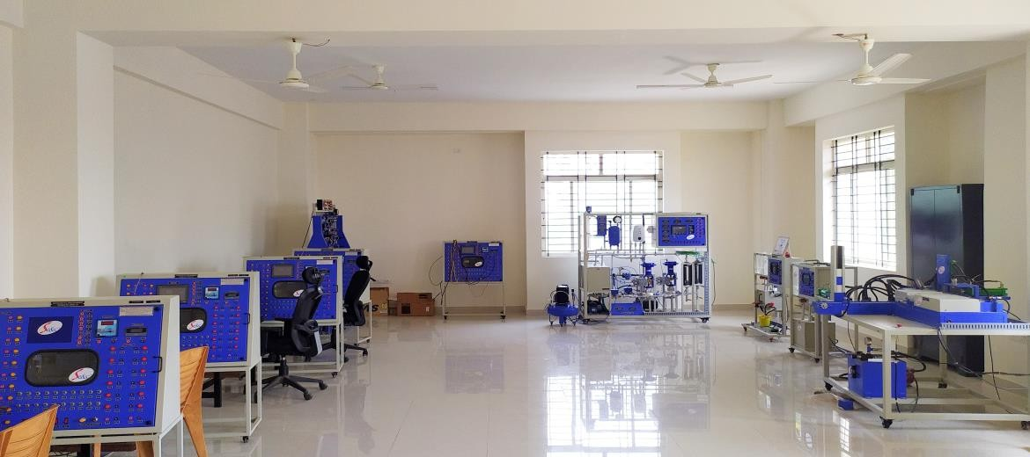

**Advanced Industrial Electro-Hydraulic System**

The industrial hydraulic system is a power transmission system using oil to carry the power. The power may be transmitted directly to the load or may be transmitted in the form of control. The greatest and finer the signal, the more positive, reliable, accurate, and responsive the control.

The inputs and outputs of any power and control system including the hydraulic are mechanical such as a rotating or a reciprocating plunger. An advantage of the system is that this system is easily adaptable to a variety of energy forms and the signals may be initiated by electrical, chemical, manual, optical, or electronic/digital.

|  |  |  |
| --- | --- | --- |
| S. No | Name of the Course | Duration |
| 1 | Advanced Industrial Electro-Hydraulic System | 40 Hours |

**Hardware Equipped**

* Different Types of Valves and Actuators
* Different types of Sensors
* Relays, Hydraulic equipment

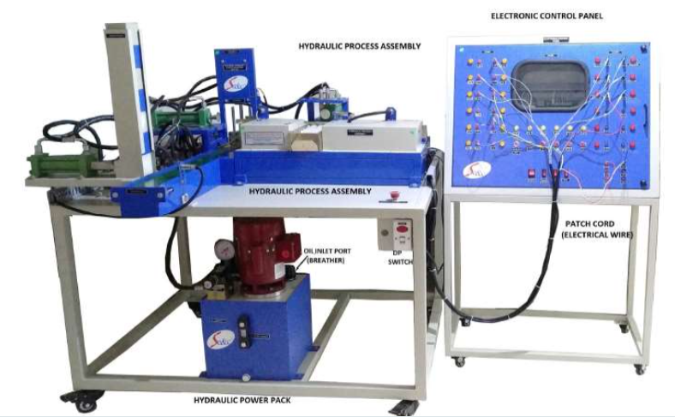

**Table of Contents**

Introduction of Hydraulic System 8

Schematic Diagram of Hydraulic System: 8

Types of Hydraulics System: 9

Stationary hydraulics 9

Mobile hydraulics: 11

Applications of Hydraulics: 12

The fundamental principle of Hydraulics. 12

Pascal’s Law 13

Pressure transmission: 15

Flow rate: 16

Pressure measurement: 16

Energy and power: 17

Cavitation 18

Introduction of Hydraulic Control system 19

Tasks for hydraulic fluids: 19

Types of hydraulic fluid 20

Hydraulic oils 20

Components of Hydraulic System 20

Hydraulic Pressure Distributor Unit 20

Hydraulic Pumps: 21

Positive displacement pump 21

Non-Positive Displacement Pump 23

Centrifugal pumps: 23

Component 23

Different Types of Valves are available for hydraulic Systems. 24

Filters: 25

Hydraulic filter is essential in order: 25

Breather 25

Directional Control Valve of Hydraulic System: 27

Direction Control valve 27

2/2 Direction Control Valve 27

Sliding pool type 2/2 DCV 28

3/2 Directional Control valve: 28

4/2 Direction Control Valve (Sliding Pool Type) 30

4/3 Direction Control Value- Closed Center 31

Closed center Type 31

4/3 Direction Control Value- Open Center: 31

Open Center Type 32

Tandem Center Type 32

Regenerative Center Type 32

Float Type Center 33

Different types of valves: 33

Check valve 33

Normal Check Valve 34

Pilot Check valve 34

Flow Control Valve: 35

Types of Flow Control Valves 36

Fixed Restriction FCV 36

Variable Restriction FCV 36

FCV with Reverse Free Flow 37

Application examples 37

One Way Flow Control valve 38

2-Way Flow Control Valve: 39

Different types of pressure valves: 39

Pressure Valves 39

Pressure relief valves 39

Pressure Relief Valve 39

Direct Acting Relief valve: 41

Pilot operated Relief Valves 41

Brake Valve 43

2-way Pressure Regulator: 44

3-way pressure regulator 46

Brake valve with 4/2 DCV: 46

Brake valve with 4/3 DCV: 47

Counter Balance Valve: 48

Pressure Reducing Valve 49

Hydraulic Exercises 51

Exercise -1 51

Exercise 2: 52

Hardening Furnace Cover Control 55

Exercise Description: 55

Basic electrical fundamentals 56

Electrical Component Fundamentals 57

Power Supply Unit: 57

Push button and control switches 57

Changeover Contact: 58

Changeover contact 58

Limit Switches: 59

Proximity switches 59

Reed switch: 59

Inductive proximity sensors: 60

Capacitive Proximity Sensors: 61

Optical proximity sensor: 62

One-way light barrier: 62

Reflective light barrier 62

Diffuse reflective optical sensor 63

Pressure sensors 63

Mechanical pressure switch 64

Electronic pressure switches 64

Analogue pressure sensors: 64

Relay: 65

Applications of relays: 65

Retentive relay: 66

Time relay: 66

Contactor: 66

Applications of contactors: 67

Introduction to programmable logic controllers (PLCs): 67

Design and representation of Hydraulic System 69

Hydraulic System Design 69

Function diagram 70

Drive 72

Pump: 72

Displacement volume 72

Operating pressure: 73

Coupling: 73

Reservoir: 74

Filters: 74

Heaters: 74

Electro Hydraulic Exercise Session-1 75

Hydraulic Circuit and Electrical circuit design with Fluid Sim demo software. 75

Sorting Device: 75

Exercise -2: Distribution of Cartons on Conveyor 77

Basics of Micro 800 series PLC 79

Features 80

PLC program Examples 80

# Introduction of Hydraulic System

Hydraulics is the generation of forces and motion using hydraulic fluids which represents the medium for the transmission of power. Hydraulic systems are extremely important for the operation of heavy equipment’s.

* Hydraulics is a vast industry having a large number of applications in our world.
* Mentioning all the applications and examples of hydraulic systems are not possible.
* In this session we can discuss some of the examples of hydraulic system.
* Vehicle breaks, steering, and lifts are common applications of the hydraulic system in daily life.

## Schematic Diagram of Hydraulic System:

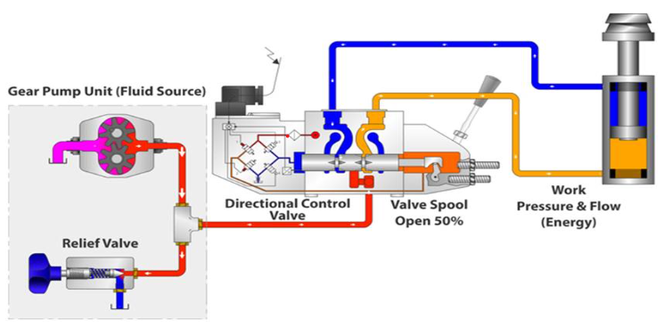

## Types of Hydraulics System:

### Stationary hydraulics

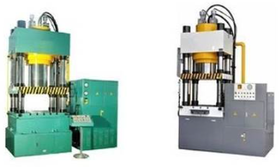

The following application areas are important for stationary hydraulics:

* Production and assembly machines of all types
* Transfer lines
* Lifting and conveying devices

#### **Presses**

* The common use for hydraulic pressing is primarily used for forging, clinching, molding, blanking, punching, deep drawing, and metal forming operations. With the growth and importance of light -weighting in the aerospace and automotive industry, more applications are constantly developing in Thermoplastics, Composites, SMC Sheet Molded Composites, RTM Resin Transfer Molding, GMT Glass Mat Transfer and Carbon Fiber Molding. All of these applications require precise control and repeatability.
* It can be used for crushing cars. A hydraulic press is always at the heart of any crushing system. The process involves using a hydraulic motor, which applies a large.
* Pressure on the fluids of the cylinders. The fluid makes the pressure plate rise with a great amount of force, which therefore makes the pressure plates crush the car.
* Injection moulding machines
* Rolling lines

#### **Lifts**

* Hydraulic lifts are used for moving goods or people vertically. Scissor lifts, two-post lifts, four-post lifts, carousel lifts, and mezzanine lifts are different types of hydraulic lifts used. Hydraulic lifts are used in automobile, shipping, waste removal, and construction applications. Cables are not used with these lifts. So, it eliminates the risk of the dead drop situation.

### Mobile hydraulics:

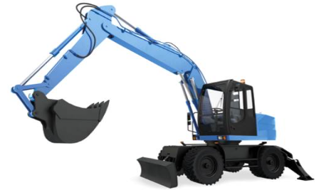

Typical application fields for mobile hydraulics include:

* Construction machinery
* Tippers, excavators, elevating platforms
* Lifting and conveying devices
* Agricultural machinery

There is a wide variety of applications for hydraulics in the construction machinery industry. On an excavator, for example, not only are all working movements (such as lifting, gripping and swivelling movements) generated hydraulically, but the drive mechanism is also controlled by hydraulics. The straight working movements are generated by linear actuators (cylinders) and the rotary movements by rotary actuators (motors, rotary drives).

## Applications of Hydraulics:

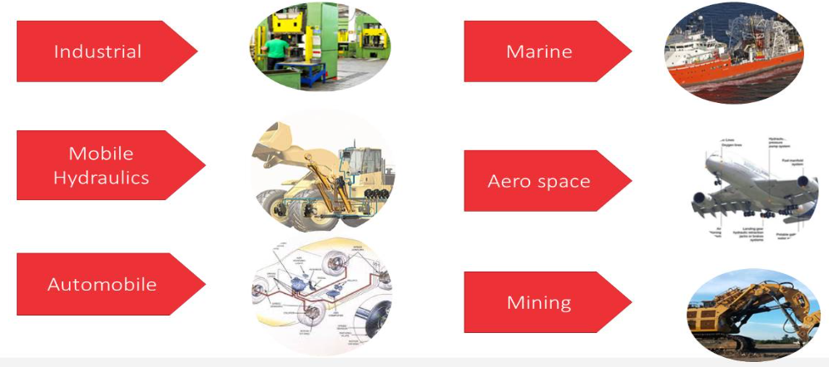

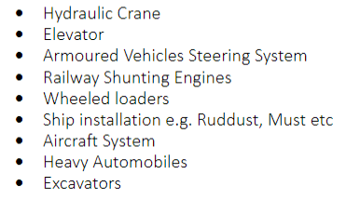

## The fundamental principle of Hydraulics.

The air, oil & water are nothing but fluids since all of them can flow. We concentrate only on oil as the hydraulic system uses oil. The operation of a fluid power system i.e. hydraulic system using oil is governed by basic physical laws of fluid flow. This law is known as “Pascal’s law”.

## Pascal’s Law

The pressure generated by exerting a force on a confined mass of liquid at rest, acts

undiminished in equal magnitude and in all direction normal to the inside wall of the fluid container.

**P=F/A**

P=Pressure

F=Force

A=Area

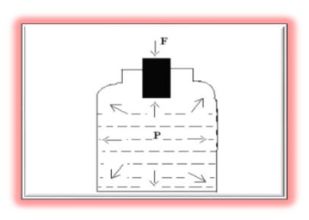

Pascal's law states that pressure exerted anywhere in a confined incompressible fluid is

transmitted equally in all directions throughout the fluid.

How Pascal’s law work?

Let us understand, how hydraulic system is based on Pascal's Law

•P1= F1/A1 and P2= F2/A2

According to Pascal's law

•P1= P2

•F1/A1= F2/A2

•F1=F2 [A1/A2]

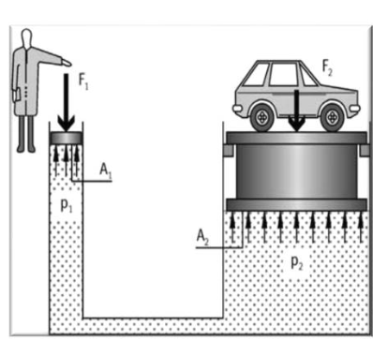

The same pressure applies at every point in a closed system. For this reason, the shape of the container has no significance.

Where a container is formed as shown in the above diagram, it is possible to transmit

forces. The fluid pressure can be described by means of the following equations:

P1=F1/A1 P2=F2/A2

The following equation applies when the system is in equilibrium:

P1=P2 (since the pressures are equal throughout)

Since pressure equals force per unit area, then it follows that

F1/A1= F2/A2

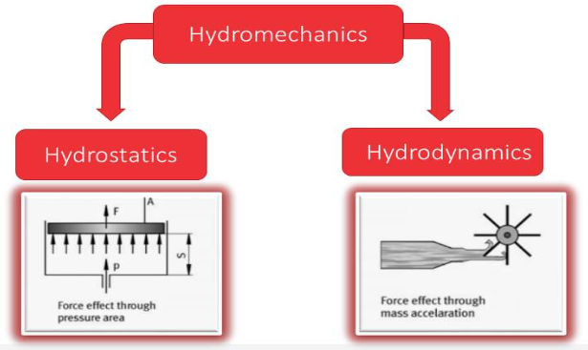

Hydraulics is the science of forces and movements transmitted by means of liquids.

It belongs alongside hydro-mechanics. A distinction is made between hydrostatics –

dynamic effect through pressure times area –and hydrodynamics –dynamic effect through mass times acceleration.

## Pressure transmission:

Owing to the fact that hydraulic systems operate at very high pressures, it is possible

To neglect the hydrostatic pressure (see example). Thus, when calculating the pressure in liquids.

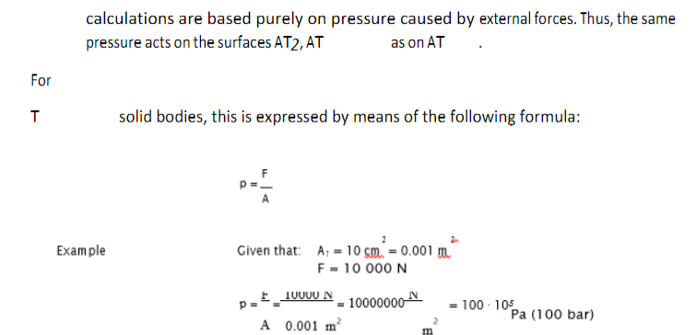

## Flow rate:

Flow rate is the term used to describe the volume of liquid flowing through a pipe in a Specific period of time. For example, approximately one minute is required to fill a 10 liter bucket from a tap. Thus, the flow rate amounts to 10l/min.

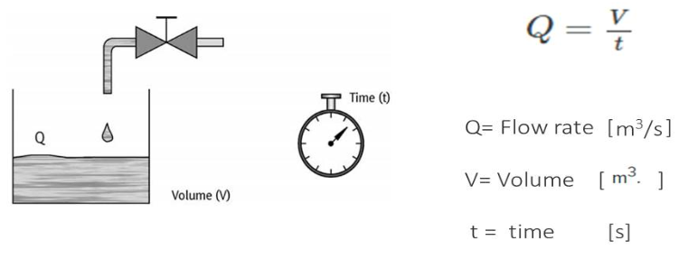

## Pressure measurement:

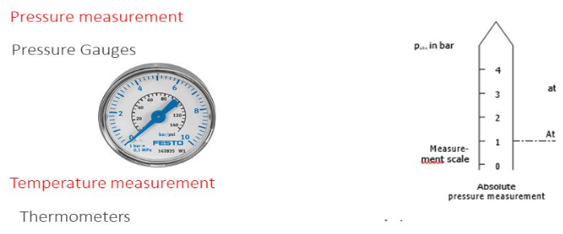

* To measure pressures in the lines or at the inputs and outputs of components, a pressure gauge is installed in the line at the appropriate point.
* A distinction is made between absolute pressure measurement where the zero point on the scale corresponds to absolute vacuum and relative pressure measurement.
* where the zero point on the scale refers to atmospheric pressure.
* In the absolute system of measurement, vacuums assume values lower than 1, in the relative system of measurement, they assume values lower than 0.

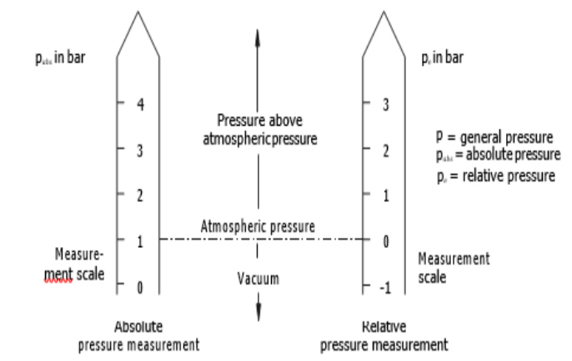

## Energy and power:

The energy content of a hydraulic system is made up of several forms of energy. As stated

in the law of conservation of energy, the total energy of a flowing liquid is constant. It only changes when energy in the form of work is externally supplied or carried away. The total energy is the sum of the various forms of energy:

•Static – Potential energy

Pressure energy

•Dynamic – Motion energy

Thermal energy

## Cavitation

• Cavitation (Lat. cavitare = to hollow out) refers to the releasing of the smallest particles from the surface of the material. Cavitation occurs on the control edges of hydraulic devices (pumps and valves). This eroding of the material is caused by local pressure peaks and high temperatures. Flash temperatures are sudden, high increases in temperature.

Motion energy is required for an increase in flow velocity of the oil at a narrowing.

This motion energy is derived from the pressure energy. Because of this, pressure drops at narrow points may move into the vacuum range. From a vacuum of pe ≤ -0.3 bar onwards, dissolved air is precipitated. Gas bubbles are formed.

If the pressure now rises again as a result of a reduction in speed, the oil causes the gas bubbles to collapse.

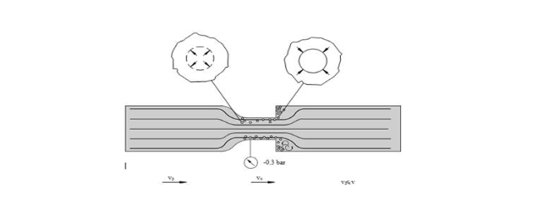

# Introduction of Hydraulic Control system

In principle, any liquid can be used to transfer pressure energy.

However, as in hydraulic installations, other characteristics are also required of hydraulic fluids, the number of suitable fluids is considerably restricted.

As a hydraulic fluid, water causes problems related to corrosion, boiling point,

freezing point and low viscosity.

Hydraulic fluids with a mineral oil base–also known as hydraulic oils– fulfil most

normal requirements (e.g. For machine tools). They are used very widely.

Hydraulic fluids with Low inflammability are required for hydraulic systems with high risk

of fire such as, for example:

* Hard coal mining
* Die – casting machines
* Forging presses
* Control units for power station turbines and steel works and rolling mills.

All these applications, there is a risk that hydraulic fluids based on mineral oils

Will catch fire on intensively heated metal parts. Oil mixtures containing water or synthetic

oils are used here in place of standard oils.

## Tasks for hydraulic fluids:

The hydraulic fluids used in hydraulic installations must fulfil very varied tasks:

* Pressure transfer,
* Lubrication of the moving parts of devices,
* Cooling, i.e. diversion of the heat produced by energy conversion (pressure losses),
* Cushioning of oscillations caused by pressure jerks,
* Corrosion protection,
* Scuff removal,
* Signal transmission.

## Types of hydraulic fluid

Within these two groups -hydraulic oils and hydraulic fluids with low inflammability.

There are various types of fluid with different characteristics. These characteristics are determined by a basic fluid and small quantities of additives.

### Hydraulic oils

In DIN 51524 and 51525 hydraulic oils are divided according to their characteristics and composition into three classes:

* Hydraulic oil HL
* Hydraulic oil HLP
* Hydraulic oil HV

## Components of Hydraulic System

### Hydraulic Pressure Distributor Unit

* Hydraulic Pressure generated from power pack unit, is available at P manifold unit,

you will avail pressure for further operation of hydraulic circuits by connecting hose

pipe (quick release coupling) to this unit.

* P Manifold: The Pressure input from the oil tank is given to the P manifold (distribution block) through Pressure relief valve.
* T Manifold: The oil is returned to the oil tank through the T Manifold.

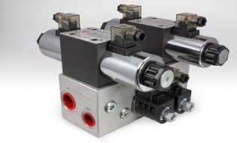

## Hydraulic Pumps:

* Hydraulic pumps are used in hydraulic drive systems and can be hydrostatic or

Hydrodynamic. A hydraulic pump is a mechanical source of power that converts

mechanical power into hydraulic energy.

* Hydrostatics is the branch of fluid mechanics that studies “fluids at rest and the

pressure in a fluid or exerted by a fluid on an immersed body”

* Hydrodynamics (the study of liquids in motion)
* Hydrostatic pumps are positive displacement pumps
* Hydrodynamic pumps can be fixed displacement pumps, in which the displacement

(flow through the pump per rotation of the pump) cannot be adjusted, variable

displacement pumps, which have a more complicated construction that allows the

displacement to be adjusted.

## Positive displacement pump

* In a positive -displacement pump, slippage is negligible compared to the pumps

Volumetric output flow.

* If the output port were plugged, pressure would increase instantaneously to the point that the pump's pumping element or its case would fail (probably explode, if the drive shaft did not break first).
* Universally used for Fluid Power.
* It pushes a fixed amount of fluid into the Hydraulic System per revolution of shaft

Gear, Vane, Piston are the examples of Positive Displacement Pump Positive

Displacement Pump.

* A Positive Displacement Pump has an expanding cavity on the suction side and a

Decreasing cavity on the discharge side.

* Liquid flows into the pumps as the cavity on the suction side expands and the liquid

Flows out of the discharge as the cavity collapses. The volume is a constant given each Cycle of operation.

* Positive displacement pumps are those whose pumping.

## Non-Positive Displacement Pump

* A non-positive-displacement pump produces a continuous flow. However, because it does not provide a positive internal seal against slippage, its output varies considerably as pressure varies. Centrifugal and propeller pumps are examples of non-positive-displacement pumps.

## Centrifugal pumps:

Centrifugal pumps are used to transport the fluids by the conversation of rotational kinetic energy to hydrodynamic energy of the fluid flow.

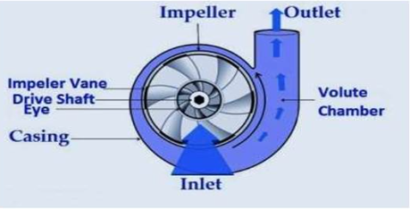

* Multi - stage pumps.
* Axial (propeller) pumps.

### Component

* Power supply section

The power supply unit provides the necessary hydraulic power –by converting the mechanical power from the drive motor.

* Hydraulic pump
* Oil filtration unit
* Hydraulic fluid
* This is the working medium which transfers the prepared energy from the power supply unit to the drive section (cylinders or motors).

### Different Types of Valves are available for hydraulic Systems.

* Directional Control valves
* Pressure Valves
* Flow Control Valves
* Non return Valve.

Note:

We will understand all the valve later because we have another session for

detail explanation of theses valves.

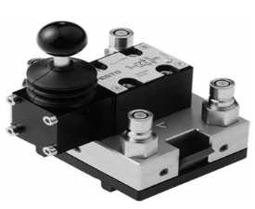

Motors (rotary actuators)

Like cylinder, hydraulic motors are drive components are controlled by valves. They too convert hydraulic power into mechanical power with the difference that they generate rotatory or swivel movements instead of linear movements.

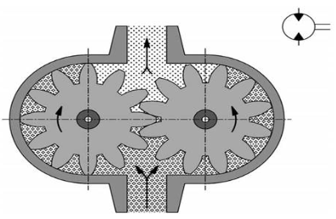

## Filters:

* Filters are of great significance in hydraulic systems for the reliable functioning and long service life of the components.

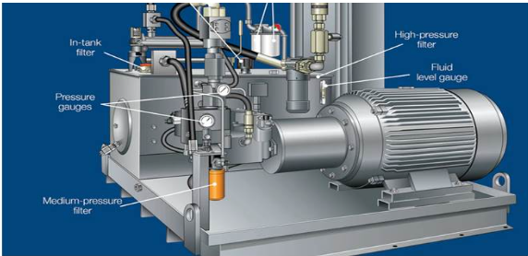

## Hydraulic filter is essential in order:

* Prevent undesirable contaminants -solids and liquid particles into the system.
* Maintain timely switching functions of control valve as designed.
* Increase life of fluid and system components.
* Maintain functional efficiency of the system and prevent operational disturbances
* Due to filtration failure. Ensure desired lubricity of oil and minimize chemical

degradation of the fluid. Reduce downtime due to maintenance shutdown.

Ensure continuous availability of the system.

## Breather

* Breathers are an integral component in any Hydraulic system. Breathers provide

Protection from contamination found in harsh industrial environments.

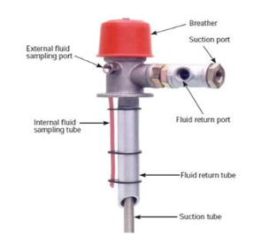

## Pumps and Motors:

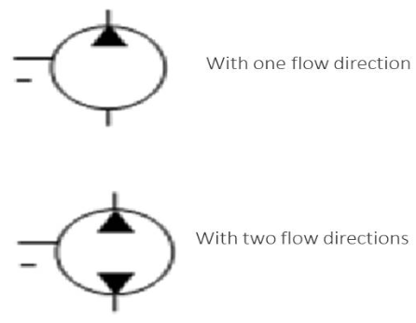

.

# Directional Control Valve of Hydraulic System:

## Direction Control valve

* Directional control valves are components which change, open or close flow paths in

hydraulic systems.

* They are used to control the direction of motion of power components and the

manner in which these stop.

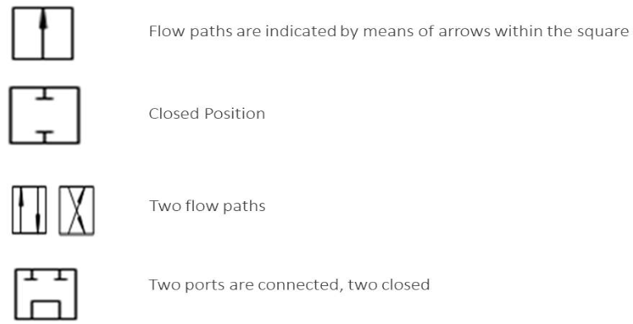,

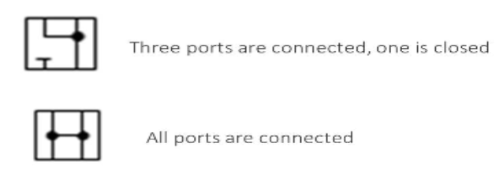

## 2/2 Direction Control Valve

* This valve has two ports and two positions of spool. The two ports are inlet port ‘A’

and outlet port ‘B.’

## Sliding pool type 2/2 DCV

* The figure shows a sliding pool type spring return type NC 2/2 DCV.
* In normal position of the spool, both the ports are closed, fluid cannot flow from Port

‘A’ to port ‘B.’

* In normal position the connection is not make from port ‘A’ to Port ‘B’

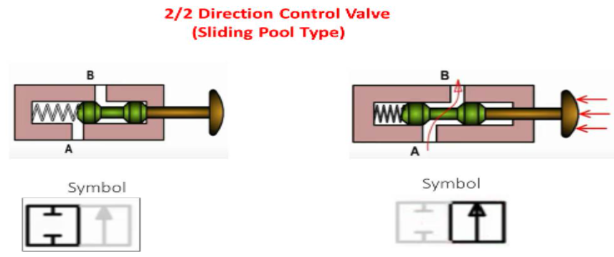

* When the Button is pressed spool moves to open the passage from Port ‘A’ to port ‘B.’
* When we press the button the connection is make from port A to Port B, hence fluid can flow from Port ‘A’ to Port ‘B’ or Port ‘B’ to Port ‘A’.

.

## 3/2 Directional Control valve:

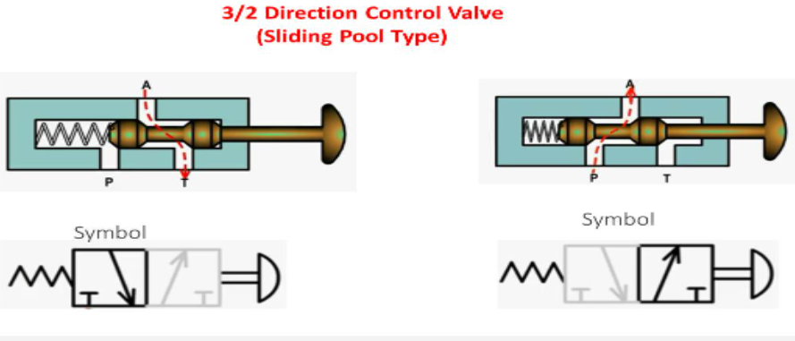

* This valve is used to operate single Acting Cylinders. It has three ports namely.

Pump port or inlet port ‘. Port A which is connected to single acting cylinder and

Tank Port or Exhaust Port ‘T’ which is connected back to the reservoir tank in

Hydraulic systems. But in pneumatic systems ‘T’ port is left open to atmosphere.

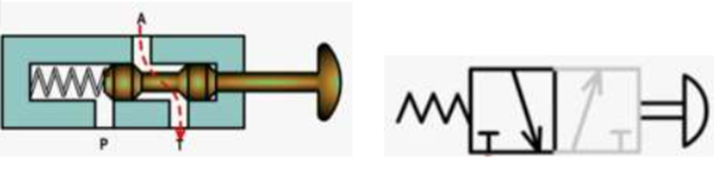

* The figure shows a spring return type sliding pool valve it has spring loaded spool inside the valve body in figure. It is hand operated type of valve.
* 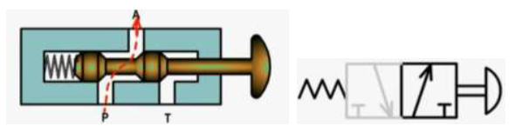In spool position as shown in figure there is connection from Port A to port T. Inlet port P is closed. In spool position as shown in figure there is connection from port A to port T. Inlet Port P is closed.
* In spool position as shown in figure, there is connection from port P to port A. The Tank Port T is closed.
* In this position when we pressed the button spring is compressed and made the

connection from port P to port A hence oil flows from pump to the cylinder.

## 4/2 Direction Control Valve (Sliding Pool Type)

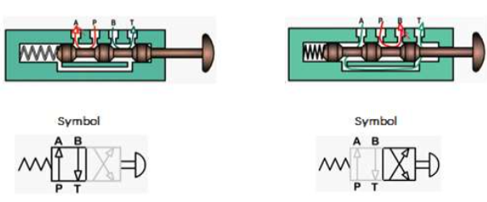

• This Valve is used to operate double acting Cylinders.

• It has four ports Pump port or inlet port P cylinder port A cylinder port B and Tank

port T.

• In spool position as shown in figure, there is connection from port P to port A and

from Port B to tank T. Fluid flows from Pump to port A and from port B to tank T.

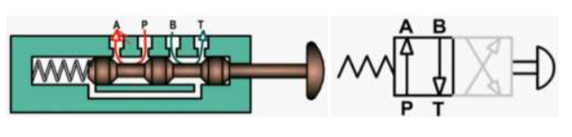

• In this position when we pressed the button spring is compressed and made the

connection from port P to port B and from port A to tank T. hence oil flows from

pump to the cylinder.

## 4/3 Direction Control Value- Closed Center

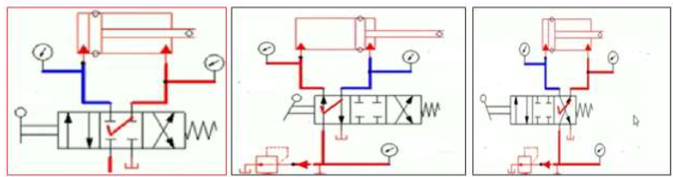

* This Valve is used to operate double acting Cylinders and bi directional motor.

It has 4 ports and 3 positions.

## Closed center Type

* Cylinder Ports A and B are closed. Hence it can hold the falling load over running

load. But pump port P is closed there is overheating of oil and power loss during idle period. power consumption is high. In the middle position of this valve, All ports are closed so the actuator stops it will not move in any direction.

## 4/3 Direction Control Value- Open Center:

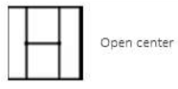

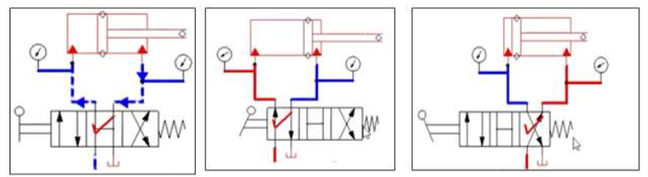

### Open Center Type

* Pump port P is open to tank port T hence it avoids over heating of oil. And saves

power during idle period. But cylinder ports A and B are connected to tank port t.

hence it cannot hold falling load over running load.

### Tandem Center Type

* Cylinder ports A and B are closed hence it can hold the falling load over running load.
* Pump port P is open to tank port Thence it avoids over heating of working fluid and

power loss during idle period. Power saving is achieved.

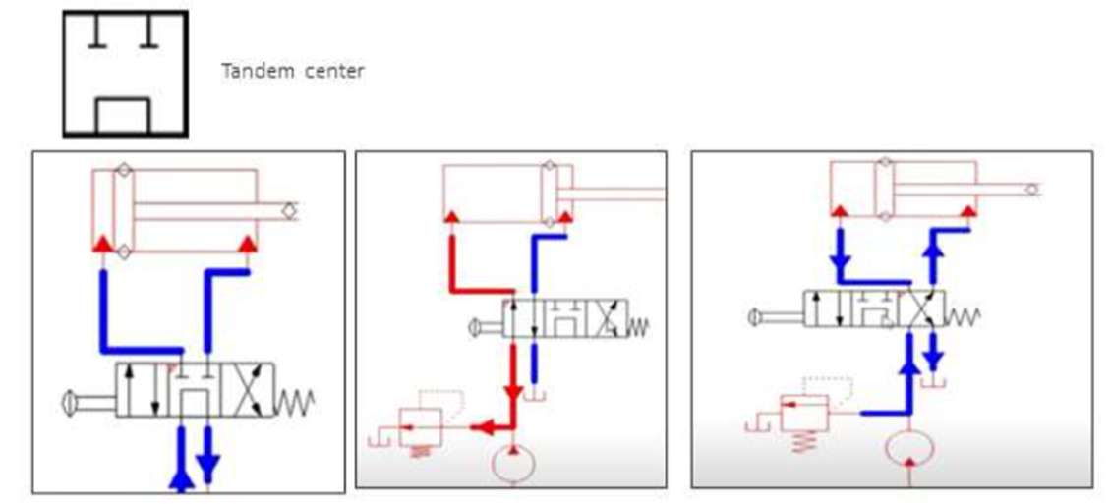

### Regenerative Center Type

* Pump port p, cylinder port A and cylinder port B all are connected. Tank port T is

closed.

* This valve is used in Regenerative circuit to have more speed during extension with

less amount of force developed.

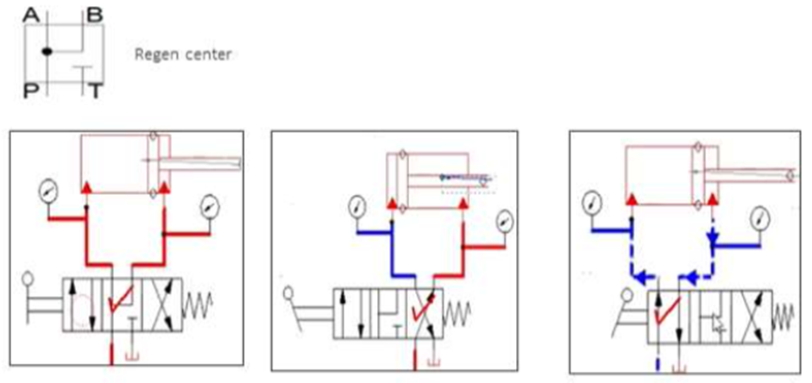

### Float Type Center

* Both A and B ports are open to tank port T. Pump port p is closed. This valve issued

in fail safe circuit (Actuator locking circuit.)

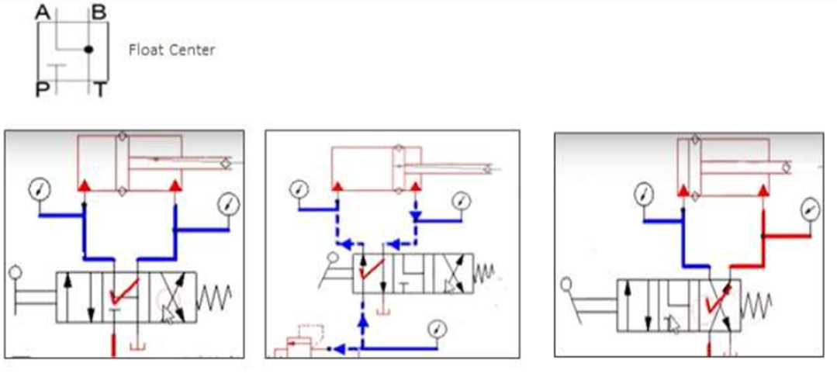

## Different types of valves:

### Check valve

* It is a unidirectional valve (nonreturn valve) which allows fluid to flow in only one

direction it will not allow fluid in other direction.

* When fluid is supplied to port A the fluid exerts pressure on the ball against the sprin

force. hence the ball will be lifted off from its seat and creates a passage for fluid to

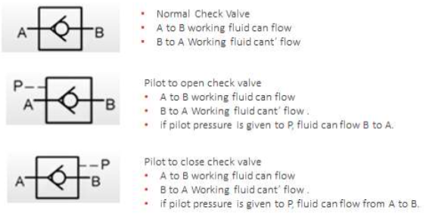 flow. Hence fluid can flow from port A to Port B.

### Normal Check Valve

* Normal check valve has only two ports. Inlet port A and Outlet Port B. Normal check

Valve is open in forward direction and closed in reverse direction.

### Pilot Check valve

* Pilot check valve has additional port called pilot port P.
* By the application of pilot pressure through the pilot port p the check valve which

was closed is made to open or the check valve which was open is made to close.

* There are two types of pilot operated check valves.
* They are pilot to open check valve and pilot to close check valve.

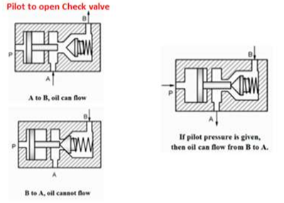

## Flow Control Valve:

* Flow control valve is used to control the rate of flow of fluid. There by to control the speed of the actuator. If flow rate of fluid is more than cylinder will be filled quickly and hence the piston will move faster.
* If flow rate of fluid is less, then cylinder will be filled slowly and hence the piston

will moves slowly. Speed of the actuator is proportional to the rate of flow hence controlling the flow controls the speed of actuator. This is achieved by flow control valves.

## Types of Flow Control Valves

* Fixed Restriction FCV
* Variable Restriction FCV
* FCV with reverse free flow
* Pressure compensated FCV
* Temperature Compensated FCV

## Fixed Restriction FCV

* This is not a valve, it is simply a restriction with a small opening (orifice), when

fitted in the system, the fluid has to flow through this small hole.

* This reduces the flow rate of fluid, but it does not have any means to vary the flow

rate or to vary the area of flow.

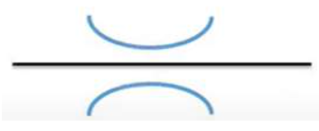

* We cannot change the area or the diameter of this orifice

## Variable Restriction FCV

* This Valve has a hand wheel or knob, by turning which, we can change the area of

flow and thus we can change the rate of flow of fluid.

* Simple water tap is the better example of understanding the functioning.

Examples are:

* Needle valve
* Gate Valve
* Ball Valve
* Butterfly Valve
* Diaphragm Valve
* Poppet Valve

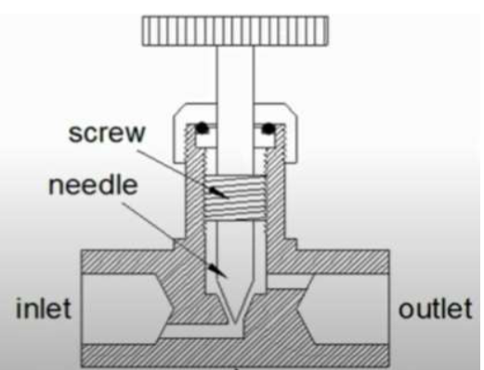

## FCV with Reverse Free Flow

* This valve is used to control the rate of flow in one Direction only in the other

direction the flow is not controlled, i.e. free flow

### Application examples

* Shapers Machine
* Planers Machine
* Slotting machine

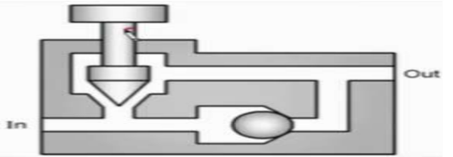

## One Way Flow Control valve

* In one-way flow control Valves, restriction is applicable only one direction and i.e. the combination of a restrictor and a non-return valve.
* The restrictor controls the flow rate in a single direction dependent on flow.
* In the opposite direction, the full cross -sectional flow is released and the return flow is at full pump delivery. This enables the on-way flow control valve to operate as follows:
* The hydraulic flow is throttled in the flow direction from A to B.
* This results in flow division as with the restrictor. Flow to the power component is reduced, the speed being reduced correspondingly.
* Flow is not restricted in the opposite direction (B to A) as the sealing cone of the non -return valve is lifted from its valve seat and the full cross-sectional flow is released.
* With adjustable one-way flow control valves, the throttling point can either be enlarged or reduced.

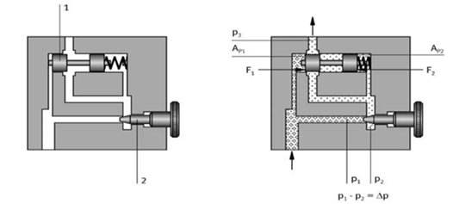

## 2-Way Flow Control Valve:

* As has already been described in the section on restrictors, there is an interrelationship between pressure drop ∆p and volumetric flow Q: ∆p ~ Q2
* If, in the case of a changing load, an even flow rate to the consuming device is required, the pressure drop ∆p via the throttle point must be kept constant. Therefore, a restrictor (2) (adjustable restrictor) and a second restrictor (1) regulating restrictor or pressure balance) are built-in for the desired flow rate.
* These restrictors change their resistance according to the pressures present at the input and output of the valve. The total resistance of the two restrictors combined with the pressure relief valve causes the flow division.

## Different types of pressure valves:

### Pressure Valves

* Pressure valves have the task of controlling and regulating the pressure in a hydraulic system and in parts of the system.
* Pressure relief valves.
* Pressure regulators.

### Pressure relief valves

* Pressure relief valves are designed in the form of poppet or slide valves.

In the normal position.

* Compression spring presses a sealing element onto the input port or slide is pushed over the opening to the tank connection.

### Pressure Relief Valve

* Pressure relief valves operate according to the following principle: The input

pressure (p) acts on the surface of the sealing element and generates the force.

F = p1 ⋅A1

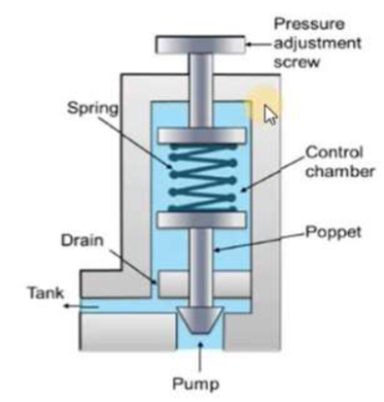

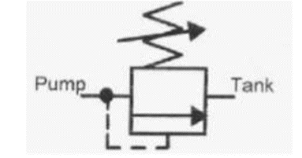

* The Pressure relief valve is one of the most important safety type of valve.

These types of valve set a limit on the rise of pressure within a hydraulic line.

* In normal operations the valve is closed and no fluid passes through. But if the pressure in line exceeds the limit, the valves open to relieve the pressure.
* This protects expensive machinery such as motors, pumps and actuators

from becoming damaged from high pressure.

* Without a relief valve a pressure can continue to grow until another component fails and pressure is released.

## Direct Acting Relief valve:

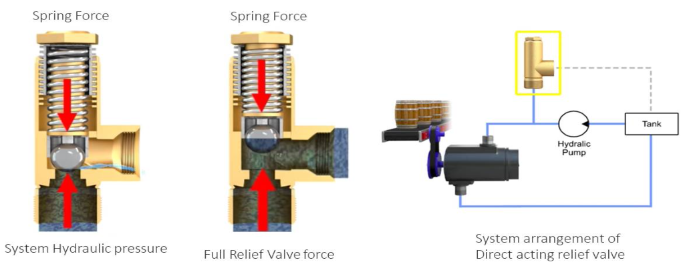

Pressure relief Valves comes in to two categories

• Direct Acting or Pilot operated

• A direct acting relief valve is held closed by the direct force of a mechanical spring

force holding the valve closed

• The spring force holding the valve closed is opposed by the system hydraulic pressure

the cracking pressure is the minimum pressure at which the valve will begin to open

this Pressure.

## Pilot operated Relief Valves

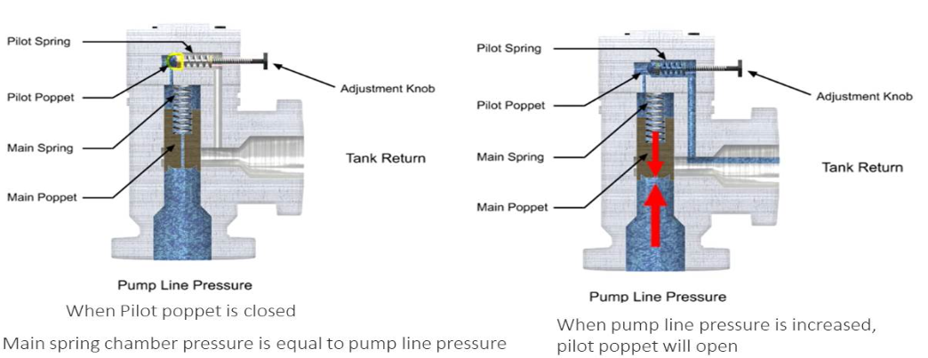

A pilot operated relief valve makes it possible to handle higher pressure and flow. it's also much smaller than direct- acting valves rated for the same pressure.

This valve has two stages

* The first stage is composed of them in valve with the poppet and spring large enough to handle the maximum flow rating of the valve.
* The second stage is composed of a much smaller direct-acting pilot valve which includes a pilot relief poppet, pilot spring and an adjusting knob.

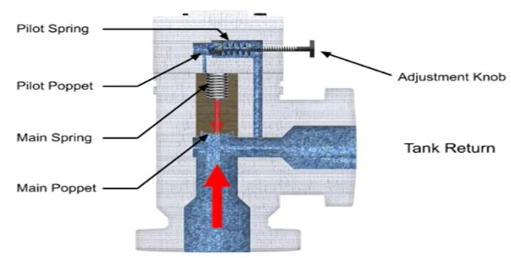

This is smaller relief valve usually mounted crosswise on the main valve body as long as a pump line pressure is less than the relieving pressure set on the control knob.

The Pilot poppet will remain closed since the pilot poppet is closed the pressure in the mainspring chamber is the same as the line pressure since this pressures are equal there is no pressure drop from one side to the other and the main poppet also remains close.

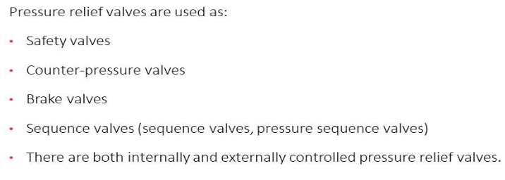

## Brake Valve

* The brake valve is used to stop the hydraulic Motors slowly and gradually
* It has a spring loaded spool, the spring tension can be adjusted by turning the

adjusting screw, by adjusting the spring tension we can set the pressure at which

the valve should open that is the time required for motor to come to rest.

* It has an inlet port I and an outlet port O.
* In normal position this valve is closed that is there is no flow from inlet to outlet
* It has an external pilot Port P when pilot pressure increases above the preset value

the valve opens and allows the oil to flow from inlet to outlet.

* It has an internal pilot connection taken from inlet of the valve itself when pressure

at inlet increases above the preset value the valve opens and allows the oil to flow

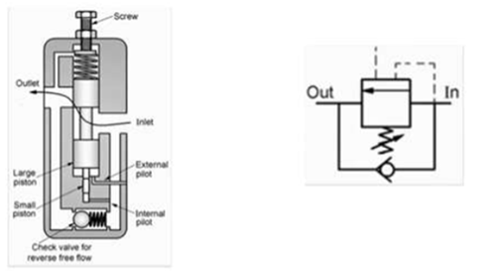 from inlet to outlet it has an integral check valve for reverse free flow.

## 2-way Pressure Regulator:

* In the case of slide valves, it is also possible to influence opening characteristics by having control edges shaped in such away that the opening gap increases slowly. This will result in greater control precision and lead to improvements in the oscillation characteristics of the valve.
* The 2-way pressure regulator dealt with earlier might be used, for example, when a constant low pressure is required for a clamping device in a by-pass circuit of the hydraulic installation.
* The 2 - way pressure regulator is rarely used in practice.
* Its design does not permit a reduction from a high set pressure to a low pressure.

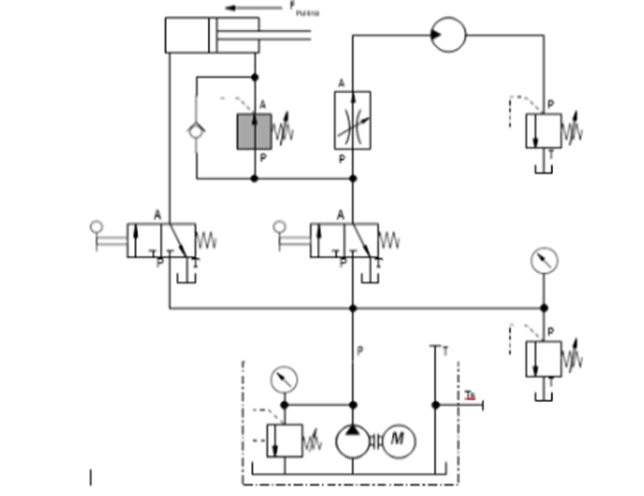

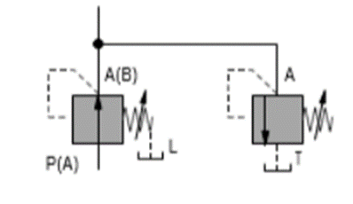

Pressure relief valve to prevent increases in pressure.

This pressure relief valve can be set in various ways:

* PRV setting greater than that for pressure regulator.
* PRV setting equal to that of pressure regulator.
* PRV setting lower than that of pressure regulator.

These settings produce various characteristics in the pressure regulator.

Another method of reducing these increases in pressure is to use a 3 –way pressure regulator.

## 3-way pressure regulator

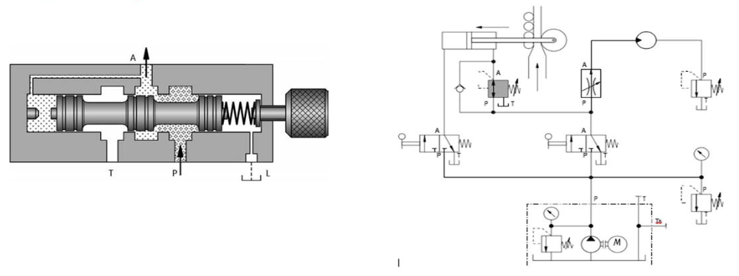

* The method of operation of a 3 – way pressure regulator is identical to that of a 2-way Pressure regulator with respect to flow from P to A.
* However, an increase in pressure above that which has been set at output (A) causes A further shift of the piston. The built – in pressure relief function comes into force and opens a passage from A to T.

## Brake valve with 4/2 DCV:

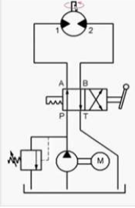

* To control the direction of the rotation of the shaft of the motor, we used 4/2 valve.
* In first position of 4/2 valve from P to A and B to T connection is there, motor will rotate in forward direction.

.

* When we shift the lever in second position oil flows from P to B and A to T, the

motor will rotate in the other direction.

* It means in one position motor rotates in forward direction, when we shift the lever to the other position. Motor runs in reverse direction.
* In first position the motor will run in clockwise direction.
* In second position the motor will rotate in anticlockwise direction.
* But when we use 4/2 DCV we can’t stop the motor. So for overcome this problem we use 4/3 DCV.

## Brake valve with 4/3 DCV:

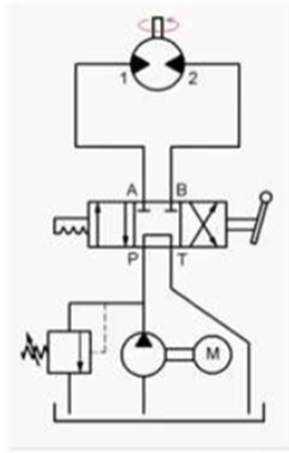

In 4/3 DCV we are having 3 positions,

First Position connection is

* P to A
* B to T

Second position connection is

* P to B
* A to T

Third position

* Middle position i.e. Tandem Centre Position
* In this position both A and B are closed and there is connection from Pump to

reservoir tank

* In first position oil flows from P to A and B to T motor runs in clockwise direction
* In the second position oil flows from P to B and A to T motor runs in anticlockwise Direction.
* When we keep the lever in middle position motor will stop because port A and B

are closed. In this case oil cannot flow from clockwise direction or anticlockwise

direction.

* To run the motor in clockwise direction use first position.
* To run the motor in anticlockwise direction use second position.
* To stop the motor use middle or tendom position.
* But the problem is when we keep the lever in middle position motor will suddenly stop and this is not desirable. It may causes accident.
* So to overcome this problem we will use Brake valve.

## Counter Balance Valve:

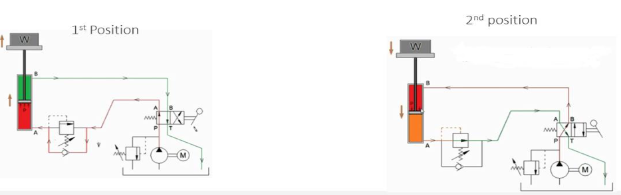

* It is used to create holding pressure in the cylinder so as to prevent falling of the load while descending.
* It is used to prevent over running load.
* In first position of 4/2 DCV, oil flows from P to A and B to T. Cylinder is extend and the load is lifted.
* In the circuit diagram, Pump, check valve, relief valve is there and motor shaft is

coupled with the pump.

* In first position of 4/2 DCV, P to A and B to T connection is there. So the oil from

pump will flow to port A of the cylinder through the check valve and it will exert.

## Pressure Reducing Valve

* Pressure reducing valve is used to maintain constant reduced pressure in the system.
* These valves are used to limit the outlet pressure.
* It’s NO type Valve.
* If the pressure at outlet increases, the diaphragm deflects upwards, due to which

conical Poppet will also move upwards to close the passage of working fluid flow. Thus the flow reduces and the pressure reduces to normal.

* Once the pressure comes to normal, the diaphragm deflects downwards and conical poppet moves downwards and it opens the passage for working fluid to flow.

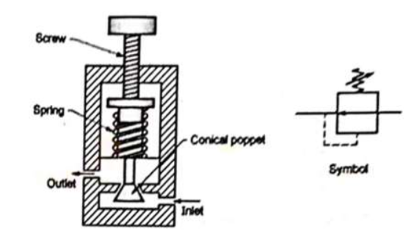

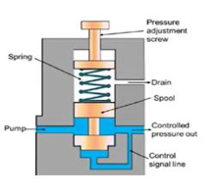

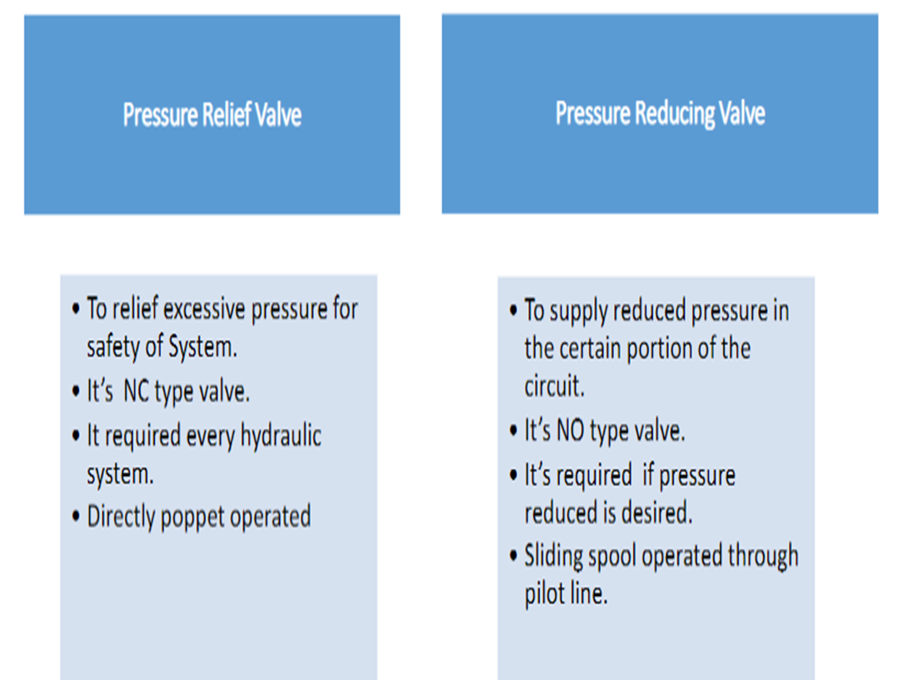

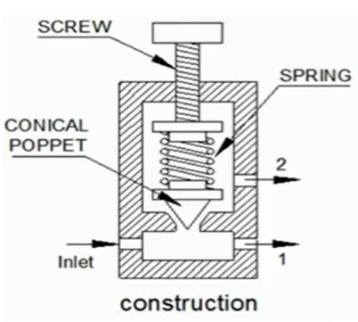During this descending of the load, the problem is weight always acts on the downward direction and the oil pressure is also in the downward direction and the headend port A is connected to tank port. Due to this weight will run at higher speed and it will produce jerk in motion and the piston will heat the end cover plates with high speed, due to which the end cover plates may get damage and oil may leak out from the end cover plates.

# Hydraulic Exercises

* Hydraulic circuit design with Fluid Sim demo software.

## Exercise -1

Exercise Description

* The table of a surface grinding machine is hydraulically actuated by a double acting cylinder controlled by a directional control valve. Since the speed should be the same in both the directions for obtaining an even surface finish, the circuit must be designed to provide compensation for the difference in volume on either side of the piston head for which a differential or regenerative circuit will be necessary.

Requirements

* A pressure relief valve to be fitted on the outlet of the pump to protect the system

from excessive pressure along with a pressure gauge to know the set pressure.

* A pressure compensated flow control valve to be used on the inlet side of the

cylinder and adjusted so that the cylinder speed is the same in both directions.

* The directional control valve to be a 3/2-way valve (use a 4/2 way with port B

blocked) for controlling the movements of the cylinder.

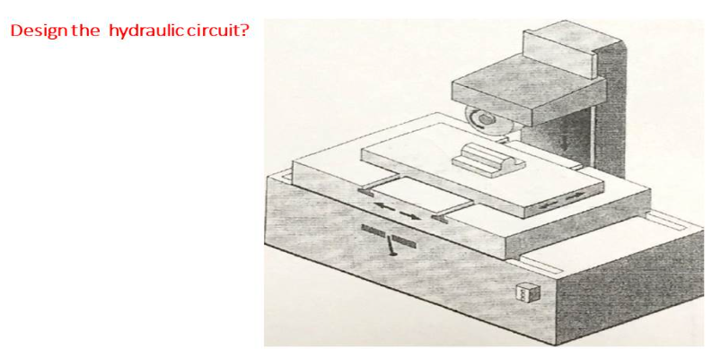

Solution:

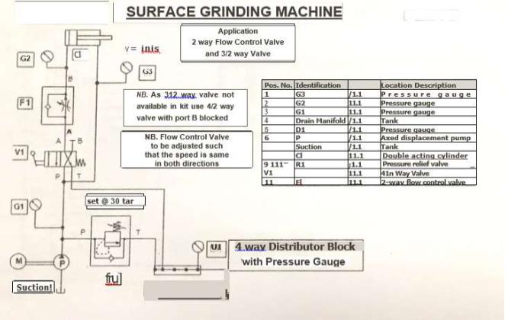

## Exercise 2:

Exercise Description

Rolls of paper are lifted into a calendaring machine by a double acting cylinder.

When the pump is switched on the pump flow is directed into the bottom of the cylinder,

thereby lifting the paper roll. When a 2/2-way valve (stop valve) is operated the cylinder

moves down.

Requirements

* A non - return valve to be used on the outlet of the pump to ensure that when the

pump is switched off the residual oil in the circuit holds the cylinder upward.

* A pressure relief valve to be fitted on the outlet of the pump after the non -

return valve to protect the system from excessive pressure.

* A pressure gauge to be fitted after the non -return valve to know the set pressure.
* A one way flow control valve to be used for controlling the fast downward speed to avoid damage to cylinder due to the impact force on reaching the bottommost position.

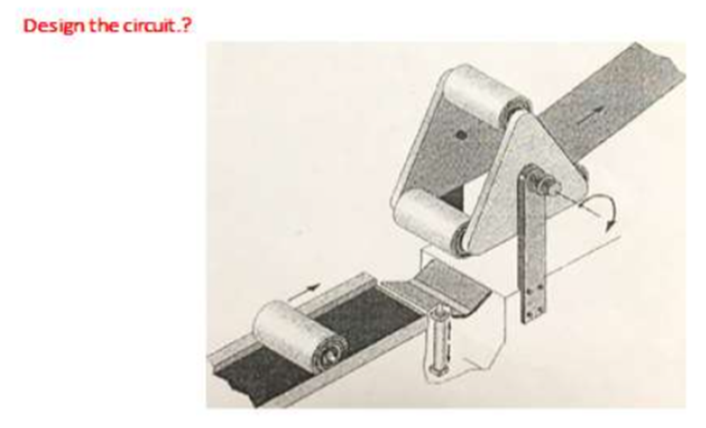

Solution:

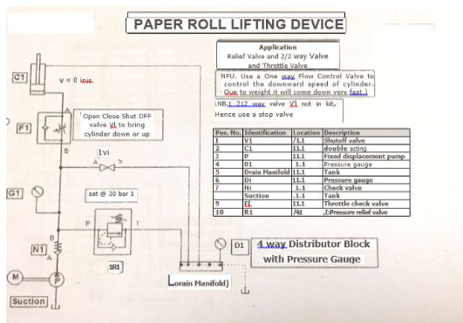

# Hardening Furnace Cover Control

## Exercise Description:

The cover of a hardening furnace is normally kept closed using a double acting

cylinder. It is lifted when a 3/2 way valve, with spring return (use a 4/2 way valve

with port B blocked) is operated and when it is released the door closes due its own

weight. A 9 kg weight attached to the top of the cylinder to represent the door weight.

**Requirements**

• Pressure relief valve to be fitted on the outlet of the pump to protect the system

from excessive pressure along with a pressure gauge to know the set pressure

•A one way flow control valve to be used to ensure the heavy door closes slowly.

•A pressure gauge to be fitted also between the flow control valve and inlet to

cylinder and to know the travel pressure.

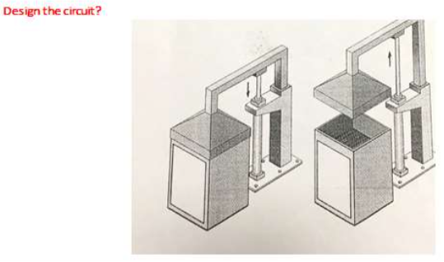

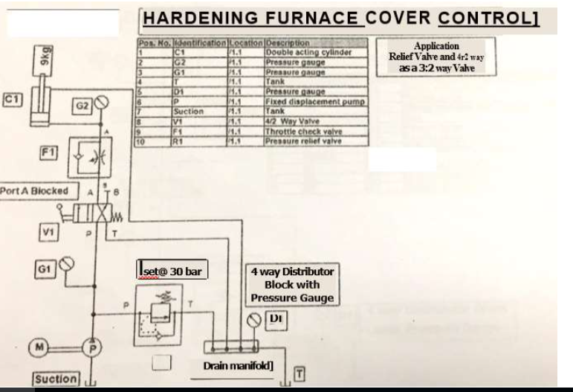

## Basic electrical fundamentals

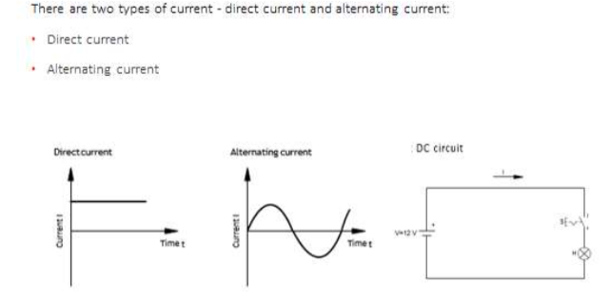

# Electrical Component Fundamentals

## Power Supply Unit:

* The signal control section of an Electro pneumatic controller is supplied with power via the electrical mains.
* The controller has a power supply unit for this (refer below diagram). The individual assembles of the power supply unit have the following tasks:
* The transformer reduces operating voltages. The mains voltage(i.e.230V) is applied to the input of the transformer. A lower voltage(i.e.24V) is available at the output smooth the voltage.
* The voltage regulator at the output of the power supply unit is required to ensure that the electrical voltages remain constant regardless of the current flowing.

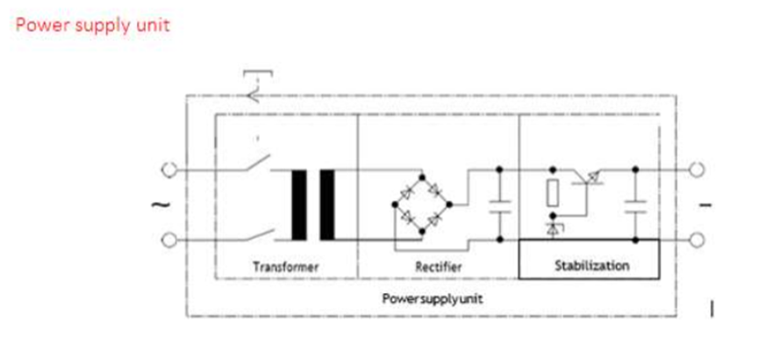

## Push button and control switches

Control switches are mechanically dettended in the selected position. The switch position remains unchanged until a new switch position is selected.

Example Light switches in the home

Push button switches only maintain in the selected position as long as the switch is actuated(pressed). Example: Bell push

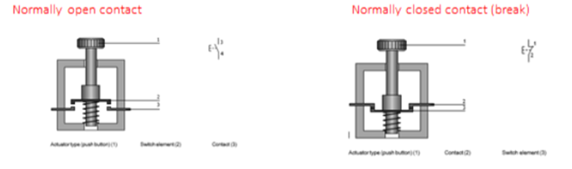

## Changeover Contact:

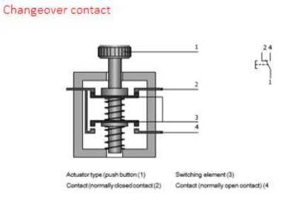

## Changeover contact

* The changeover contact combines the functions of the normally open and

normally closed contacts in one device. Changeover contacts are used to close

one circuit and open another in one switching operation.

* The circuits are momentarily interrupted during changeover.

## Limit Switches:

* A limit switch is actuated when a machine part or work piece is in a certain position. Normally, actuation is affected by a cam. Limit switches are normally

changeover contacts. They can then be connected – as required – as a normally open contact, normally Closed contact or changeover contact.

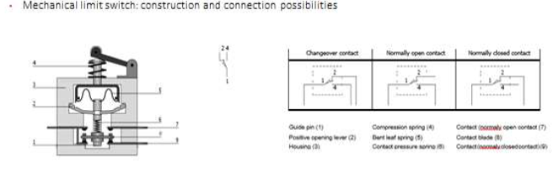

## Proximity switches

* Reed switch
* Inductive proximity switch
* Capacitive proximity switch
* Optical proximity switch

## Reed switch:

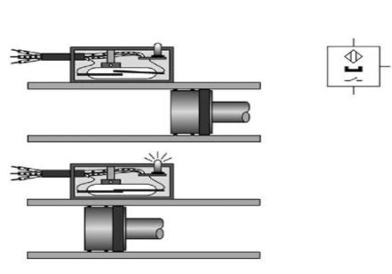

* The reed switch/contact is an electrical switch operated by an applied magnetic field. It consists of a pair of contacts on ferrous metal reeds in a hermetically sealed glass envelope.
* The contacts may be normally open, closing when a magnetic field is present, or normally closed and opening when a magnetic field is applied. The switch may be actuated by a coil, making a reed relay, or by bringing a magnet near to the switch. Once the magnet is pulled away from the switch, the reed switch will go back to its original position.

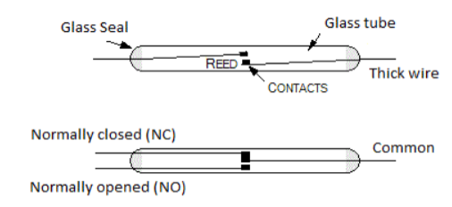

Reed switches are small in size, which makes them easy to mount and unobtrusive,

and the fact that the operating force required to operate the switch is very small.

Reed switches, and suitable magnets, are also cheap and easily obtainable.

Positive and negative switching sensors

1. In positive switching sensors, the output voltage is zero if no part is detected in the proximity.

2. In negative switching sensors. The supply voltage is applied to the output if no part

is detected in the proximity

## Inductive proximity sensors:

Inductive proximity sensors can be used for the detection of all good electrical conductors(materials). In addition to metals, these include, for example, graphite.

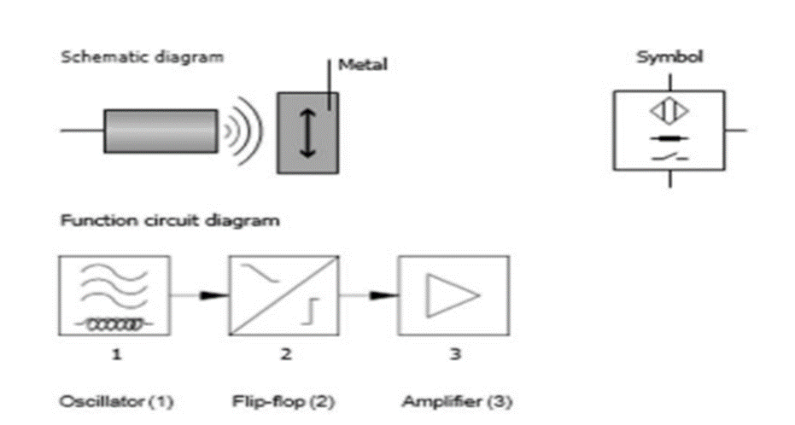

* An inductive proximity sensor is a type of non-contact electronic proximity sensor that is used to detect the position of metal objects.
* The sensor incorporates an electromagnetic coil which is used to detect the presence of a conductive metal object.
* The sensor will ignore the presence of an object if it is not metal. When a metal target enters the field, eddy currents circulate within the target.

## Capacitive Proximity Sensors:

* Capacitive proximity sensors are similar to inductive proximity sensors. The

main difference between the two types is that capacitive proximity sensors

produce an electrostatic field instead of an electromagnetic field. Capacitive

proximity switches will sense metal as well as non- metallic materials such as

paper, glass, liquids, and cloth.

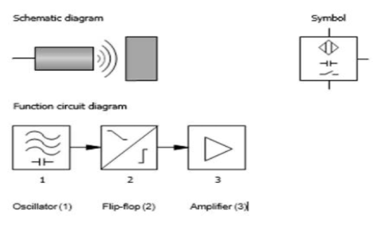

## Optical proximity sensor:

Three different types of optical proximity switch are differentiated:

1. One-way light barrier
2. Reflective light barrier
3. Diffuse reflective optical sensor.

## One-way light barrier:

The one-way light barrier has spatially separate transmit and receiver units.

The parts are mounted in such a way the transmitter beam is directed at the receiver.

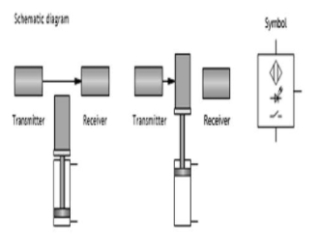

## Reflective light barrier

* In the reflective light barrier, the transmitter and receiver are mounted together in one housing. The reflector is mounted in such a way that the light beam transmitted by the transmitter is practically completely reflected to the receiver. The output is switched if the beam is interrupted.

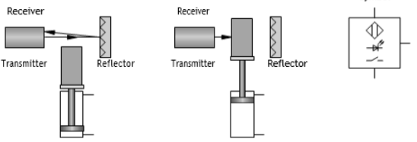

## Diffuse reflective optical sensor

* In the diffuse reflective optical sensor, the transmitter and receiver are mounted together in one unit.
* If the light hits a reflective object, it is redirected to the receiver and causes the output of the sensor to switch. Because of the functional principle, the diffuse reflective optical
* Sensor can only be used if the material or machine part to be detected is highly reflective (for example polished metal surfaces, bright paint).

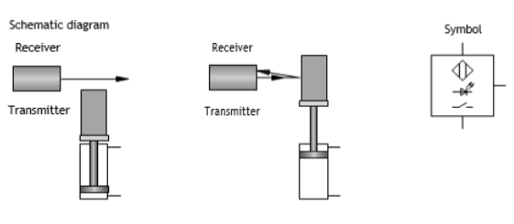

## Pressure sensors

There are various types of pressure -sensitive sensors:

* Pressure switch with mechanical contact (binary output signal)
* Pressure switch with electronic switching (binary output signal)
* Electronic pressure sensor with analogue output signal.

## Mechanical pressure switch

* In the mechanically actuated pressure switch, the pressure acts on a cylinder surface. If the pressure exerted exceeds the spring force of the return spring, the piston moves and operates the contact set.

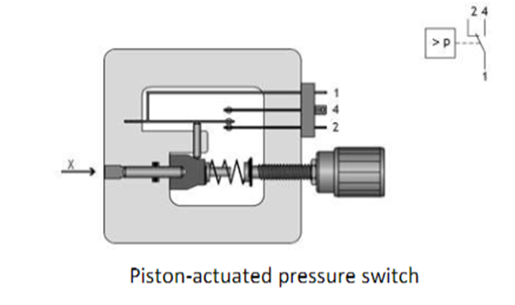

## Electronic pressure switches

* Diaphragm pressure switches are of increasing importance. Instead of actuating a Mechanical contact, the output is switched electronically. Pressure or force sensitive sensors are attached to the diaphragm. The sensor signal is evaluated by an electronic circuit.

## Analogue pressure sensors:

* The design and mode of operation of an analogue pressure sensor is demonstrated using the example of the Festo SDE -10 -10V/20mA sensor. Fig shows the piezo resistive measuring cell of a pressure sensor. Variable resistor1 changes its value when pressure is applied to the diaphragm. Via the contacts 2, the Resistor is connected to the electronic evaluating device, which generates the output signal.

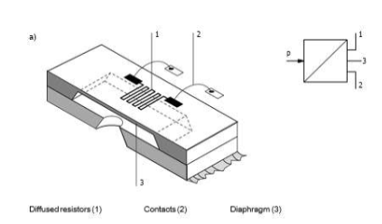

## Relay:

A relay is an electrically operated switch. Many relays use an electromagnet to mechanically operate a switch, but other operating principles are also used, such as solid state relay. Relays are used where it is necessary to control a circuit by a low power signal, or where several circuits must be controlled by one signal. Solid state relays control circuits with no moving parts, instead using a semiconductor device to perform switching.

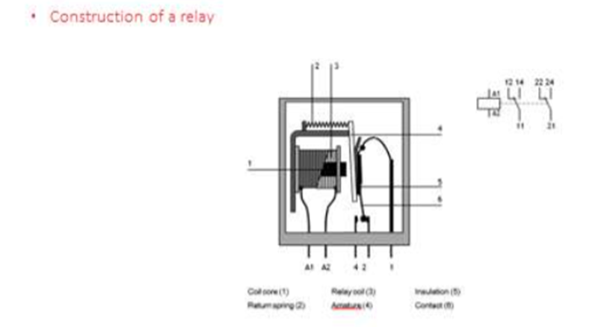

## 

## Applications of relays:

1. In electro pneumatic control systems, relays are used for the following functions:
2. Signal multiplication.
3. Delaying and conversion of signals.
4. Association of information.
5. Isolation of control circuit from main circuit.

## Retentive relay:

1. The retentive relay responds to current pulses:
2. The armature is energized when a positive pulse is applied.
3. The armature is de energized when a negative pulse is applied
4. If no input signal is applied, the previously set switch position is retained (retention).

## Time relay:

* There are two types of time relay – pull -In delay and drop –out delay.

With pull - in delay, the armature is energized after a set delay; drop – out however, is effected without delay.

* The reverse applies in the case of the drop – out delay relay, whereby the contacts

Switch accordingly.

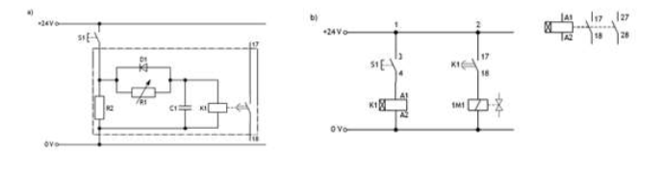

## Contactor:

A contactor has multiple switching elements, normally four to ten contacts. For contactors as for relays – there are various types with combinations of normally open contact, normally closed contact, changeover contact, and delayed normally closed contact etc. Contactors that only switch auxiliary contacts (control contacts) are called contactor relays. Contactors with main and auxiliary contacts are called main or power contactors.

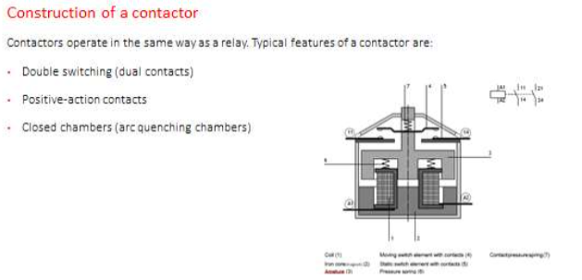

## Applications of contactors:

Contactors are used for the following applications:

* Currents of 4 to 30 kW are switched via the main contacts of power contactors.
* Control functions and logical associations are switched by auxiliary contacts.
* In electro pneumatic controllers, electrical currents and power are low. For this reason, they can be implemented with auxiliary contactors. Main or power contactors are not required.

# Introduction to programmable logic controllers (PLCs):

Control engineering has evolved over time. In the past humans were the main methods

for controlling a system. More recently electricity has been used for control and early electrical control was based on relays. These relays allow power to be switched on and off without a mechanical switch. It is common to use relays to make simple logical control decisions. The development of low cost computer has brought the most recent revolution, the programmable logic controller (PLC). The advent of the PLC began in the 1970s, and has become the most common choice for manufacturing controls.

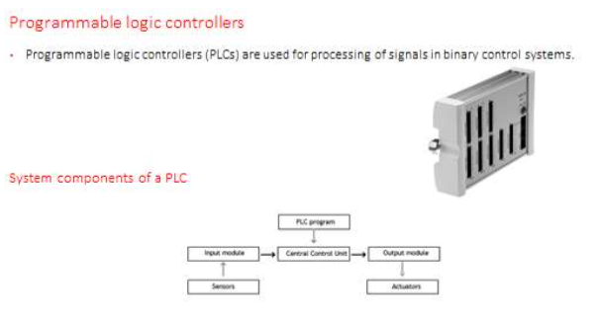

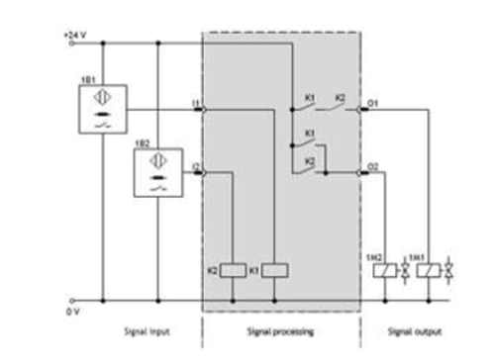

The signal processing part of an electro pneumatic controller consists of three function

blocks. Its structure is shown in above figure.

Signal input takes place via two sensors or via push button or control switches.

* Fig. shows two proximity digital switches for signal input.
* Signal processing is normally undertaken by a relay control system or a PLC

## Design and representation of Hydraulic System

### Hydraulic System Design

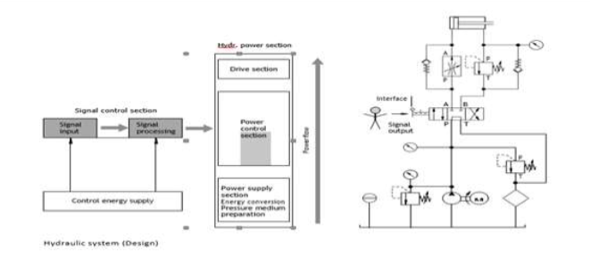

* The Hydraulic power can be divided up into the power supply section, the power

control section and the drive section. the power supply section is made up of the

energy conversion part and the and the pressure medium conditioning part.

* In this part of the hydraulic system the hydraulic power is generated and the

pressure medium conditioned. The following components are used for energy

conversion – converting electrical energy into mechanical and then into

hydraulic energy.

* Electric motor
* IC Engine
* Coupling
* Pump
* Pressure Indicator
* Protective Circuitry

The following components are used to condition the hydraulic fluid.

* Filter
* Cooler
* Heater
* Thermometer
* Pressure Gauge
* Hydraulic fluid
* Reservoir
* Filling level Indicator

The positional sketch is a drawing or schematic diagram of a production installation or

Machine etc. It should be easily understandable and should only the most important

Information.

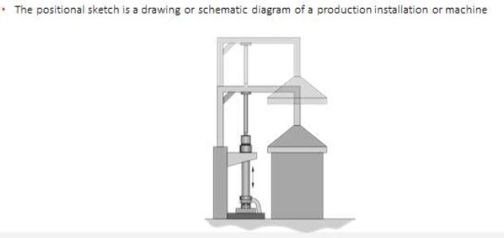

## Function diagram

* Function diagrams of working machines and production installations can be

represented graphically in the form of diagrams. These diagrams are called function diagrams. They represent statuses and changes in status of individual components of a working machine or production installation in an easily understood and clear manner.

* The following example shows a lifting device controlled by electromagnetic directional control valves.

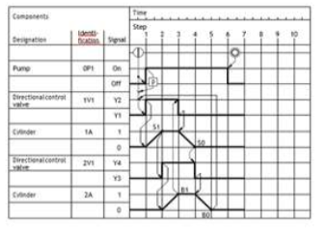

* A function chart is a flow chart in which the control sequence is strictly divided

into steps.

Each steps executed only after the previous step has been completed and all step

Enabling conditions have been fulfilled.

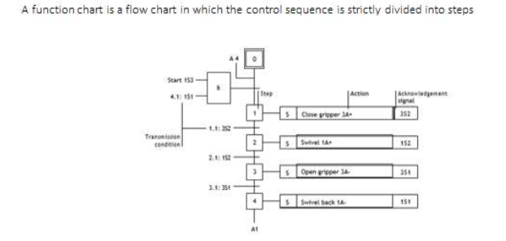

## Drive

* Hydraulic systems (with the exception of hand pumps) are driven by motors (electric motors, combustion engines). Electrical motors generally provide the mechanical power for the pump in stationary hydraulics, whilst in mobile hydraulics combustion engines are normally used.

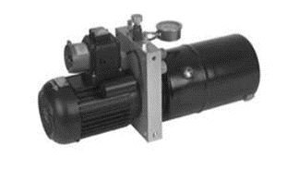

## Pump:

The pump in a hydraulic system, also known as a hydraulic pump, converts the mechanical energy in a drive unit into hydraulic energy (pressure energy).The pump draws in the hydraulic fluid and drives it out into a system of lines. The resistances encountered by the flowing hydraulic fluid cause a pressure to build up in the hydraulic system. The level of the pressure corresponds to the total resistance which results from the internal and external resistances and the flow rate.

External resistances: come about as a result of maximum loads and mechanical friction and static load and acceleration forces.

## Displacement volume

* The displacement volume V (also known as the volumetric displacement or working volume) is a measure of the size of the pump. It indicates the volume of liquid supplied by the pump per rotation (or per stroke).
* The volume of liquid supplied per minute is designated as volumetric flow rate Q (delivery). This is calculated from the displacement volume V and the number of Rotations n:

Q = n ⋅V

## Operating pressure:

* The operating pressure is of significance for the area of application of pumps.

Peak pressure is specified. However, this should arise only briefly (see diagram) as otherwise the pump will wear out prematurely.

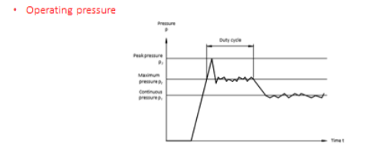

## Coupling:

* Couplings are located in the power supply section between the motor and the pump. They transfer the turning moment generated by the motor to the pump.

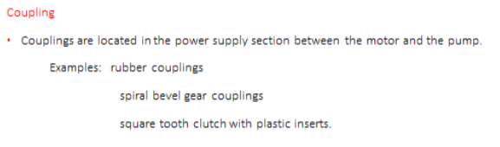

## Reservoir:

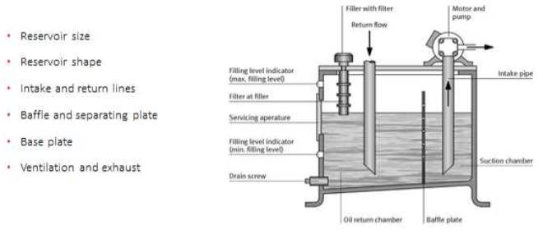

## Filters:

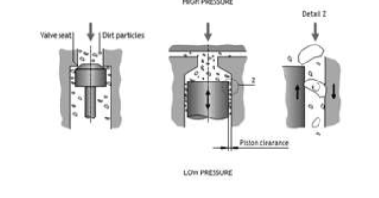

## Heaters:

* Heaters are often required to ensure that the optimum operating temperature is

quickly attained. The aim of this is to ensure that when the system is started up, the hydraulic fluid quickly reaches the optimum viscosity. Where the viscosity is too high, the increased friction and cavitation lead to greater wear.

* Heating elements or flow preheaters are used for heating and preheating hydraulic fluid.
* The aim of this is to ensure that when the system is started up, the hydraulic fluid quickly reaches the optimum viscosity, where the viscosity is too high, the increased friction and cavitation lead to greater wear.

# 

# 

## 

# Electro Hydraulic Exercise Session-1

## Hydraulic Circuit and Electrical circuit design with Fluid Sim demo software.

### Sorting Device:

Exercise Description

* A hydraulic sorting device is used for sorting of heavy steel work from one conveyor to another. When a push switch is pressed and held the piston of a double acting cylinder pushes the work piece to adjacent conveyor and on releasing it the piston rod retracts to home position.

When the pump is switched on the pump flow directly enters in.

Requirements

* A pressure relief valve to be fitted on the outlet of the pump to protect the system from excessive pressure.
* A pressure gauge to be fitted on the outlet of the pump to know the pressure set on the relief valve.
* A 4/2-way single solenoid controls the movement of the cylinder.

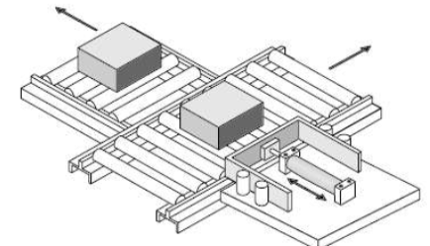

**Solution:**

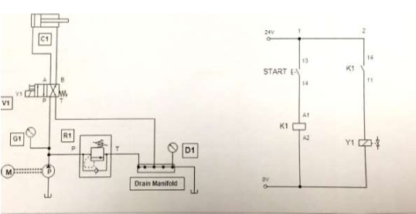

# 

# Exercise -2: Distribution of Cartons on Conveyor

Excersise Description

* A hydraulic device is used for sorting of cartons from one conveyor to another. When a push switch is kept pressed the piston of a double acting cylinder pushes the work piece to adjacent conveyor. When another push switch is kept pressed the piston rod retracts to home position. The forward speed must be slow and adjustable.

Requirements

* A pressure relief valve to be fitted on the outlet of the pump to protect the system from excessive pressure.
* A pressure gauge to be fitted on the outlet of the pump to know th e pressure set on the relief valave.
* A 4/3 way double solenoid valve,closed centre controls the movement of the cylinder.
* A one way flow control valve is connected on the rod side of the cylinder to control the forward speed.

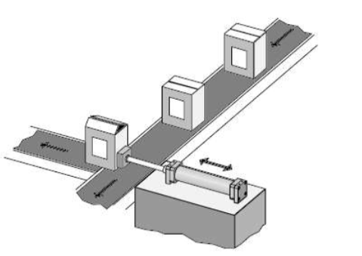

**Solution:**

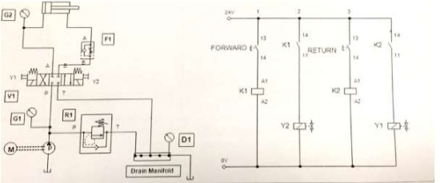

# Basics of Micro 800 series PLC

* The new Allen -Bradley Micro820 20pt controller is specifically designed for small

Standalone machines and remote automation projects with embedded Ethernet and Serial ports.

* The PLC used in this trainer is Allen Bradley Make, Miro820. The Model No. is 2080-LC20 -20QBB.
* The PLC has 12 digital inputs and 8 digital outputs.
* It operates on 24VDC.
* Micro820™ Programmable Logic Controller Systems include a nano-sized footprint and are designed for small standalone machine control and remote automation applications that require flexible communications and I/O capabilities.
* These controllers support up to 36 I/O points with many embedded features such as Ethernet, micro SD slot for recipe and data log, and analog I/O.

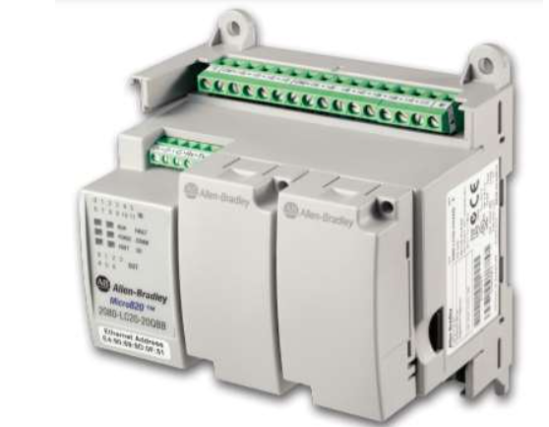

## Features

* Offers 20- point controllers
* Provides embedded 0...10V non isolated 4 channel analog input and 1 channel analog output for speed control of an AC drive.
* Provides embedded communications via non- isolated serial port (for RS -232 and RS-485 communications) and Ethernet port Communicates via Ether Net/IP™.

## PLC program Examples

**Continuous Filling Operation:**

* To control the product filling from the hooper, Solenoid will be activated after the box positioned (proximity switch activation and again de-activates after the level switch activated (level full).

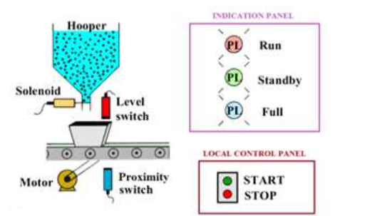

**Solution:**

